Linear Regression 2.1: Predicting Goal Difference in FIFA World Cup 2026 Matches
1. Data, objective and modelling design
The modeling goal was to estimate the match goal difference (A-B) for all matches played in the FIFA World Cup 2026. The response and predictors were constructed as pre-match team-A-minus-team-B differences wherever appropriate, so the model estimates relative match advantage rather than absolute team strength.
Eight predictors were tested: FIFA points difference, difference in the number of days a team had to rest before the tournament, difference in estimated travel-distance, difference in cumulative extra-time minutes, difference in points per game in the previous 30 matches played, difference in clean-sheet-rate in the previous 30 matches played, difference in the number of games played within the previous 30 days, and the difference in host-status. This was a dataset with 104 distinct matches with no missing data or duplicated match ID fields. Multicollinearity did not pose a serious threat as the highest VIF value was 3.22.
To be sure, the design of the experiments was made as general as possible, and not actually reduced to a single linear regression model. To avoid information leakage, scaling, winsorising and transformations were fitted in folds of training sets. The OLS, Ridge, Lasso, ElasticNet, alternative predictor subsets, antisymmetry/no-intercept specification, winsorisation, a signed-log travel transformation, and random-forest and gradient-boosting benchmarks were assessed. Evaluation was based on repeated 5-fold cross-validation 10 times.
2. Exploratory analysis: what the data suggest before modelling
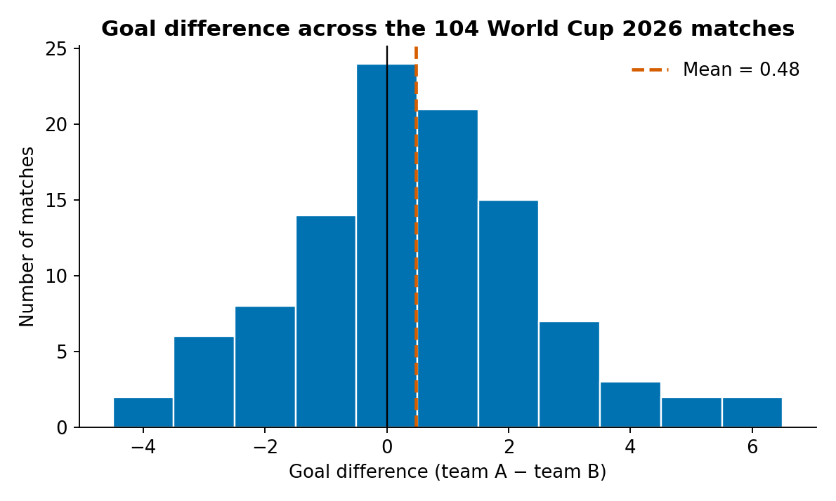
Figure 1. Distribution of match goal difference across the 104 matches. The target is discrete and centred close to zero, with a small number of high-margin matches that can strongly affect RMSE.
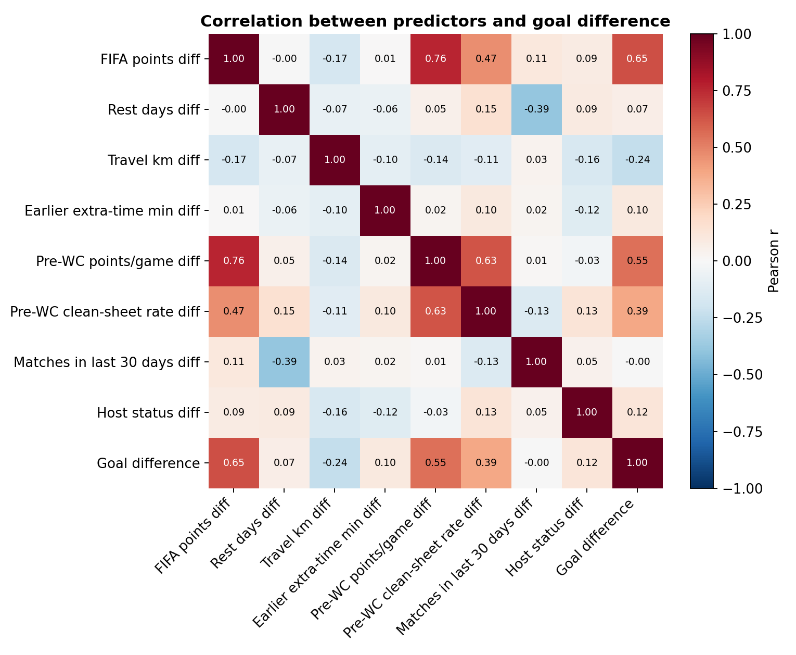
Figure 2. Correlations among candidate predictors and goal difference. FIFA points and pre-tournament points per game show the strongest positive relationships with the target.
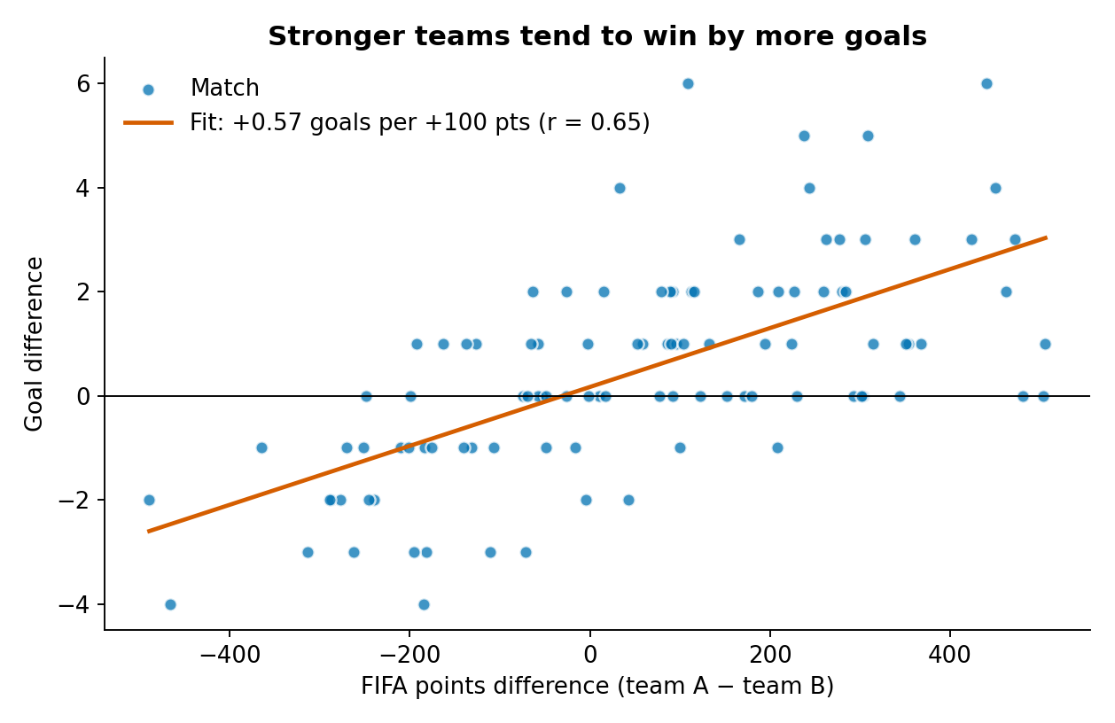
Figure 3. FIFA-points difference versus goal difference. The fitted relationship provides the clearest visual evidence that stronger teams tend to win by larger margins.
3. Systematic experimentation and model selection
The 19 experiments were organised into four questions: (1) does a linear model improve on a mean-only baseline; (2) do regularisation methods improve generalisation; (3) do transformations, winsorisation or structural constraints help; and (4) do non-linear learners outperform the linear approach? This design makes the model-selection process traceable rather than choosing a method after seeing a single favourable result.
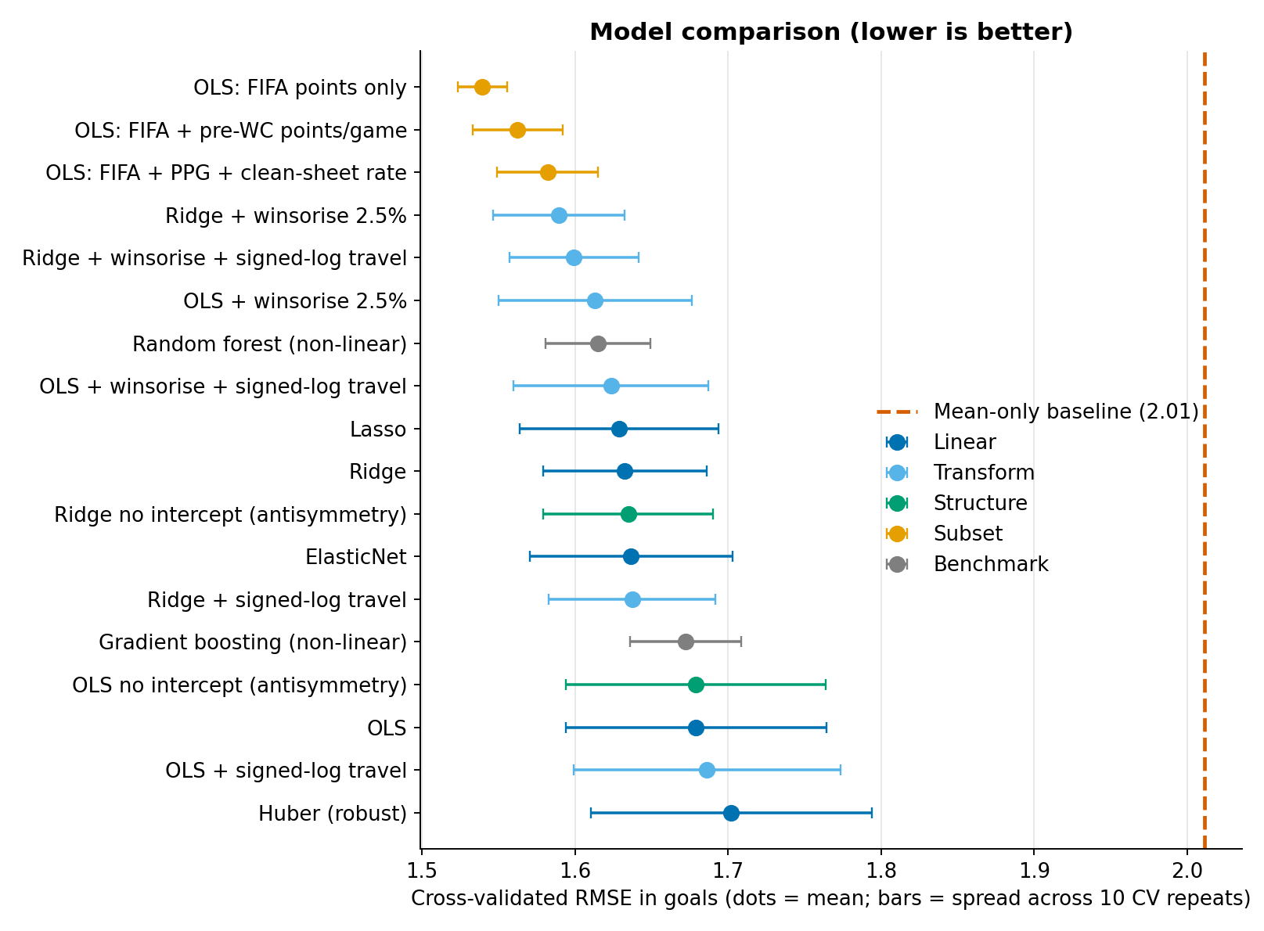
Figure 4. Cross-validated RMSE across all 19 experiments. Points show mean RMSE and horizontal bars show variation across the 10 repeated cross-validation runs; lower values are better.
The baseline using 'mean' resulted in a CV RMSE of 2.011. OLS brought it down to 1.679, with Ridge with 2.5%/97.5% winsorisation giving the best linear result of 1.590 (CV MAE 1.264; CV R2 0.316) with all eight predictors. The averaged improvement on the OLS was about 5.3% and was present in all the repeated runs of CV conducted. Random forest had a score of 1.615 and gradient boosting scored 1.672; yet no preferential evidence for introducing a more complex non-linear learner had been discovered.
Notably, the highest numerical accuracy was not in the final eight-predictor model: FIFA with FIFA points alone yielded CV RMSE 1.540. We therefore treated predictor parsimony as a separate modelling question rather than hiding this result. The feature selection mechanism in the in-fold selected FIFA points as the best single predictor in all 50 training folds. There was no statistical difference between this one predictor model and the final Ridge-winsorised model (p = 0.483), and it cannot be said that one model is better than the other on this basis.
4. Interpretation and model explainability
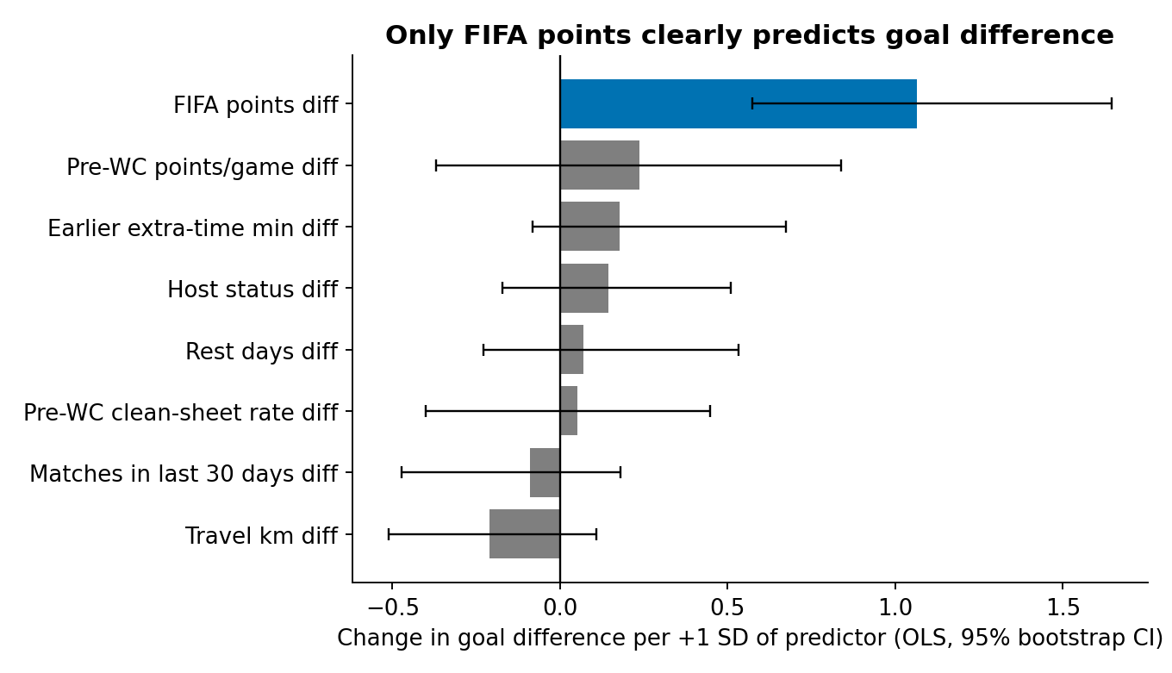
Figure 5. Standardised predictor effects from the linear model with 95% bootstrap intervals. FIFA points is the only predictor with a clearly separated positive effect.
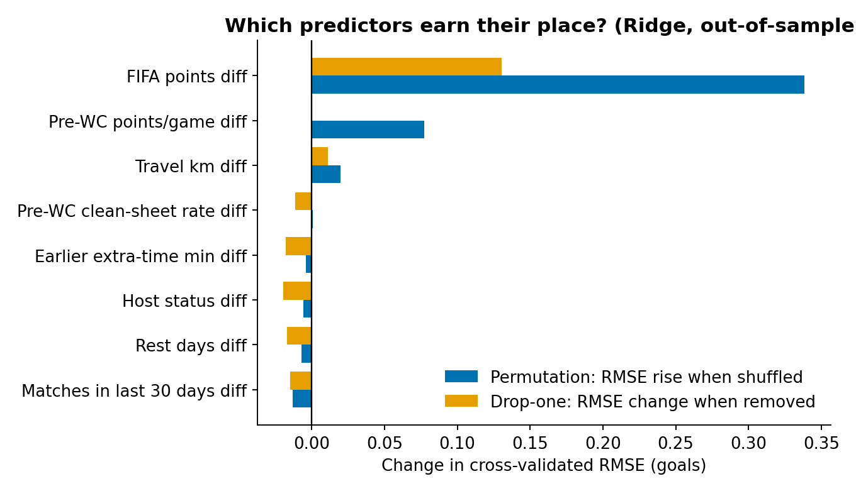
Figure 6. Out-of-sample permutation and drop-one importance for the final Ridge model. FIFA points dominates predictive contribution, while the remaining variables provide comparatively small incremental information.
The most important predictor was FIFA points difference. For the OLS inference model, a 100-point increase in team A's excess points was associated with an increase of about 0.46 points in the expected difference in goals (p < 0.001; 95% CI 0.25 to 0.67). Confidence intervals for rest days, travel distance and cumulative minutes of extra travel and for other predictors, including intervals that covered zero for rest days and minutes of extra travel. These discoveries can only be considered correlations, not causes.
The consistency of the correlation analysis, the coefficient estimates, and the in-fold feature selection and the permutation/drop-one importance strengthens the substantive conclusion: pre-match FIFA strength contains most of the predictive information within this feature set.
5. Validation, diagnostics and error analysis
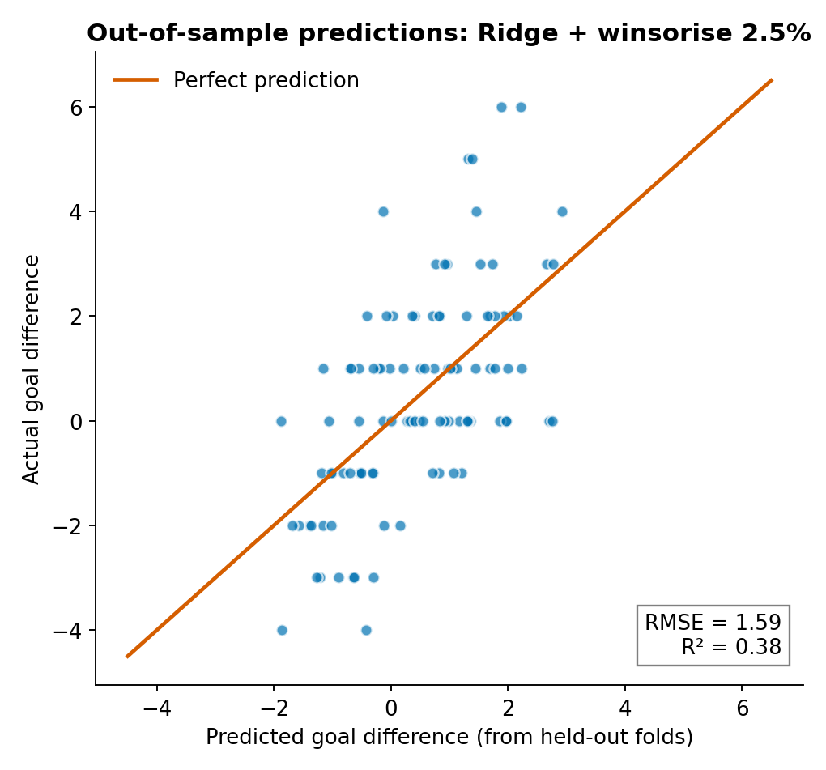
Figure 7. Out-of-sample predicted versus actual goal difference for the final Ridge-winsorised model. The spread around the 45-degree line illustrates why exact scoreline prediction remains difficult.
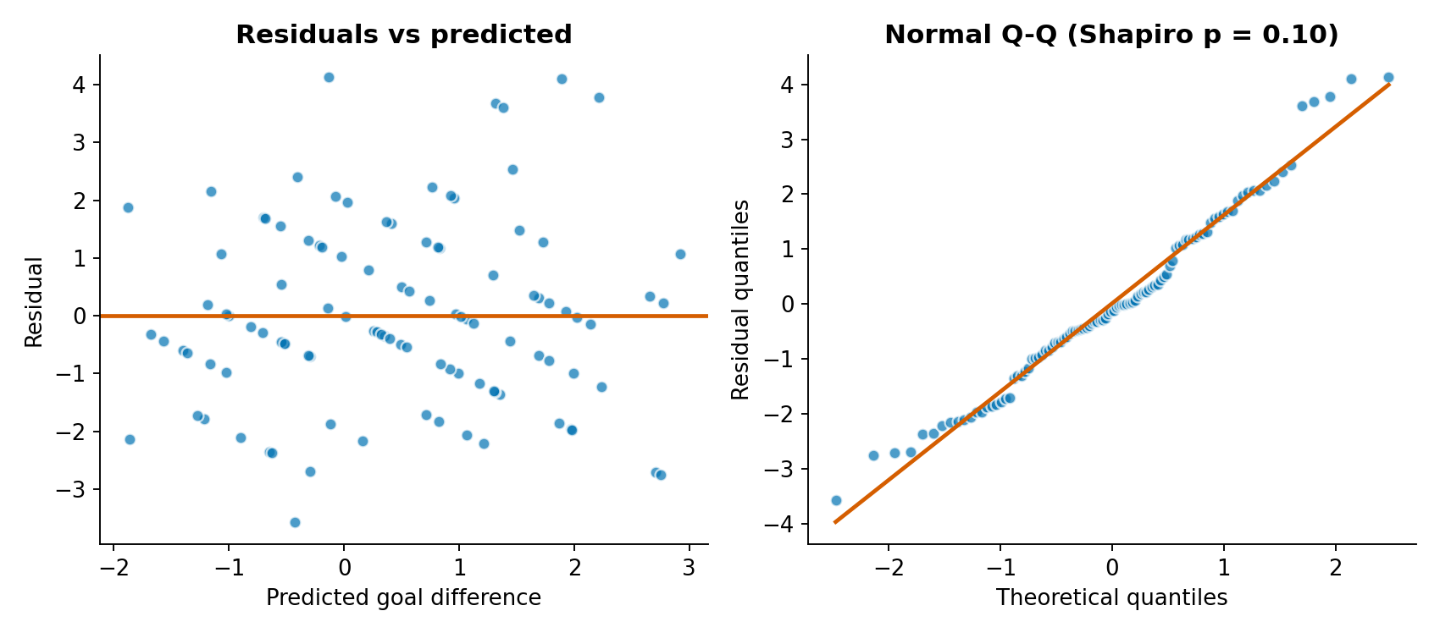
Figure 8. Residual diagnostics for the fitted model. There is no strong evidence of non-normality or heteroskedasticity in the diagnostic tests.
The residuals from the model tested showed no large modeling error; Shapiro-Wilk p = 0.18, Breusch-Pagan p = 0.68, Durbin-Watson = 2.13, with a maximum Cook's distance of 0.212. These diagnostics are helpful for the linear framework, but should not be used in small sample sizes and should, indeed, be used with some caution as evidence for perfect model adequacy, so a test of the assumptions should not be used.
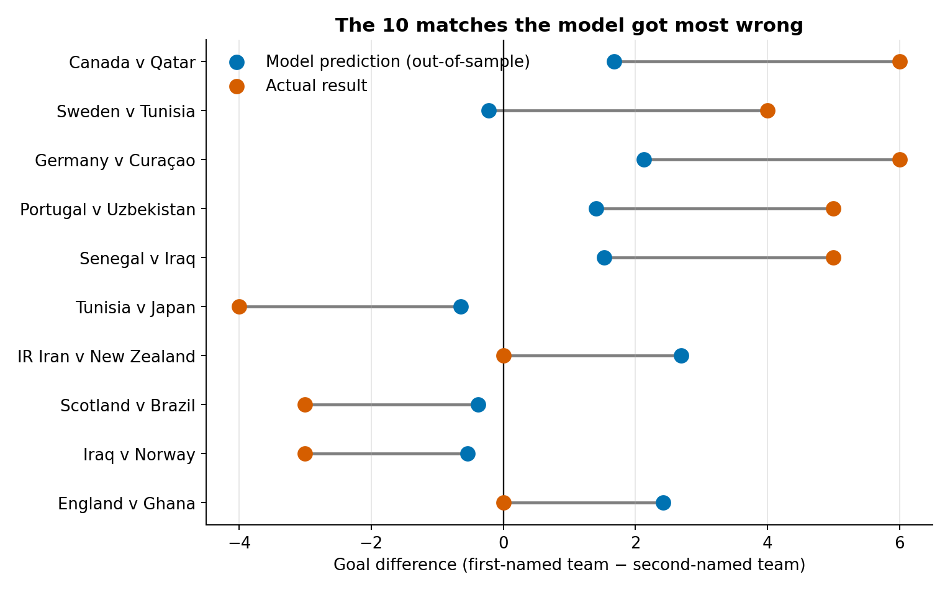
Figure 9. Ten matches with the largest out-of-sample errors. The model is most challenged by unusually large wins and some matches where the stronger pre-match team failed to win.
The model was within one goal of the game in 48% of the games and within two goals of the game for 79% of the games. These were often the results with significant margins, like Canada 6–0 Qatar, and Germany 7–1 Curaçao, that were markedly underestimated. This definition is substantially advantageous in the sense that when attempting a prediction of relative team strength and the margin it will be possible to get this correct, rather than accurately reproducing one or the other end of the scoring scale.
6. Recommendation
Among the 8 models selected based on theory, it is recommended to use the Ridge regression model 2.5% / 97.5% winsorisation as it is the most validated model among the models motivated by the theory and interpretable and less complicated than non-linear one. The points-only regime using the FIFA points system should however remain the most economical solution. There is no statistical evidence that the performance of the eight predictor model is statistically better than the one predictor model.
The model, then, should be referred to as a strength and margin predictor; it is not an absolute predictor as to what will actually happen during a game. Users are expected to provide an educated guess on a margin, include uncertainty and never make predictions or if users make individual match predictions, then they will present this as being at least 50% accurate.
7. Limitations and scientific caution
The sample size is 104, hence the number of matches is low and the extreme matches have a high influence on the statistics. The data are observational data and therefore coefficients are not utilized in order to apply a causal interpretation. Distances walked may be estimated and for some predictors there may be uncertainty in the measurement and/or construction. In addition, the significance of out-of-sample evaluation is highlighted as the cross-validation performance is significantly lower than the in-sample fit (OLS R² = 0.459 vs. about 0.32 for the final model).
The other disadvantage is that the final model wasn't the one that had the absolute lowest RMSE, as a model of points based solely on the FIFA scores had a slightly lower RMSE. When we tell this, it's not a fictional story that we created, it's just a story. The transparency is critical when the objective is to attain scientific rigour.
8. Summary of evidence against the assessment criteria
- Competitive algorithms: linear, regularised, robust and non-linear have been compared, with linear not being the best.
- Systematic experiments: There were 19 pre-specified test experiments involving models/ features/ transforms that were tested in the same repeated cross validation framework.
- Scientific rigour: leakage prevention, repeated cross validation, multiple collinear term control, residual diagnostics and paired comparisons applied.
- Interpretability: coefficient effects, bootstrapping intervals, permutation/drop one – explain how the final model works.
- Data Storytelling: visual sequence from target distribution and relationships to which models to choose, to interpretation, to validation and to failure cases.

